NAME : Selvakumar R
PROJECT TITLE : Automatic Website Hosting via S3-TO-EC2 Sync

Introduction
The project “Automatic Website Hosting via S3-to-EC2 Sync” focuses on automating website updates by syncing files stored in Amazon S3 directly to an EC2 server. This system allows any changes made in the S3 bucket to be reflected instantly on the website hosted by EC2. The goal is to show how AWS services make website hosting faster, easier, and less error-prone for students and small businesses.​

Objectives
- Automate the process of updating website files by syncing an S3 bucket with an EC2 server.
- Provide a step-by-step experience of deploying cloud solutions with AWS for beginners.
- Reduce manual file transfer workload and increase the efficiency of web hosting using cloud automation.
- Demonstrate the use of essential AWS services for a practical real-world web deployment.​

AWS Services Used
- Amazon S3: Used to store static website files (HTML, images, CSS, JS) and act as the main source for website content.
- EC2 (Elastic Compute Cloud): Hosts the actual website by running an Apache/Nginx web server that pulls files from S3.
- IAM (Identity and Access Management): Provides necessary security permissions for EC2 to access S3 buckets safely.
- AWS CLI: Used to script and automate file syncing between S3 and EC2.​
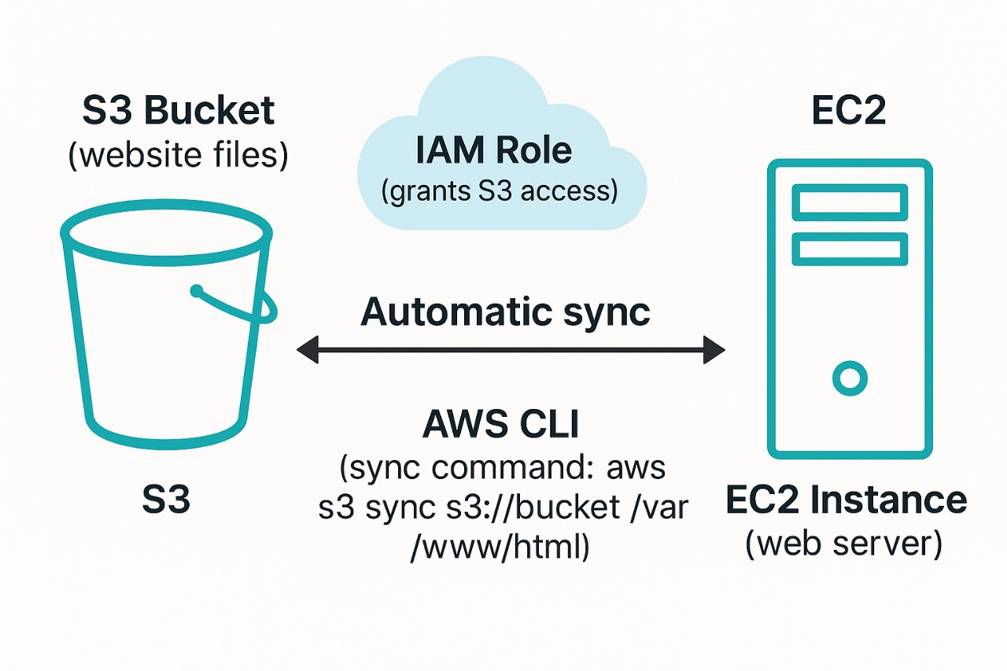

Project Implementation Details:

- Create an S3 bucket: All your website files are uploaded here as the source.
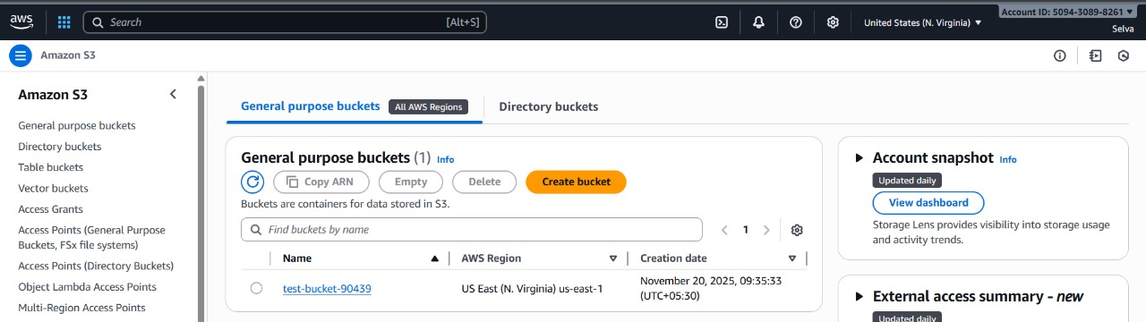
- Launch an EC2 instance: Set up Apache/Nginx web server to serve website files.
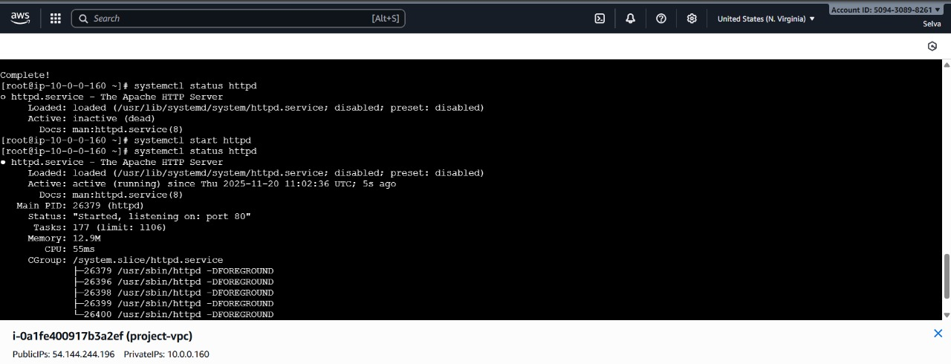

- Configure IAM Role: Attach a role to EC2 with “S3 Read” permission so EC2 can access and download files securely.
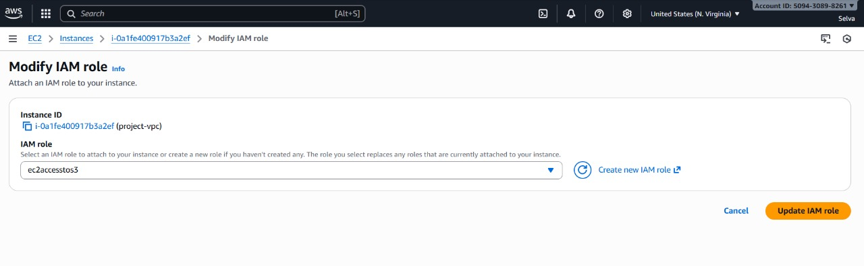

- Install AWS CLI on EC2: This lets EC2 fetch and sync files from S3 to its local web folder.


- Write & schedule sync script: Create a shell script on EC2 to run “aws s3 sync” and set up a cron job to automate syncing every few minutes.
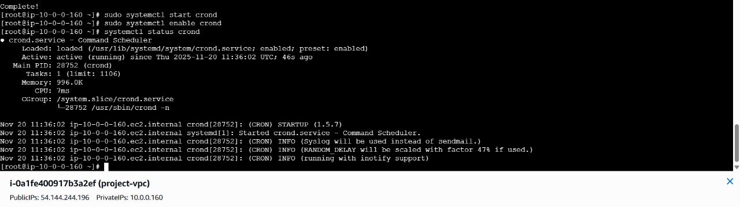
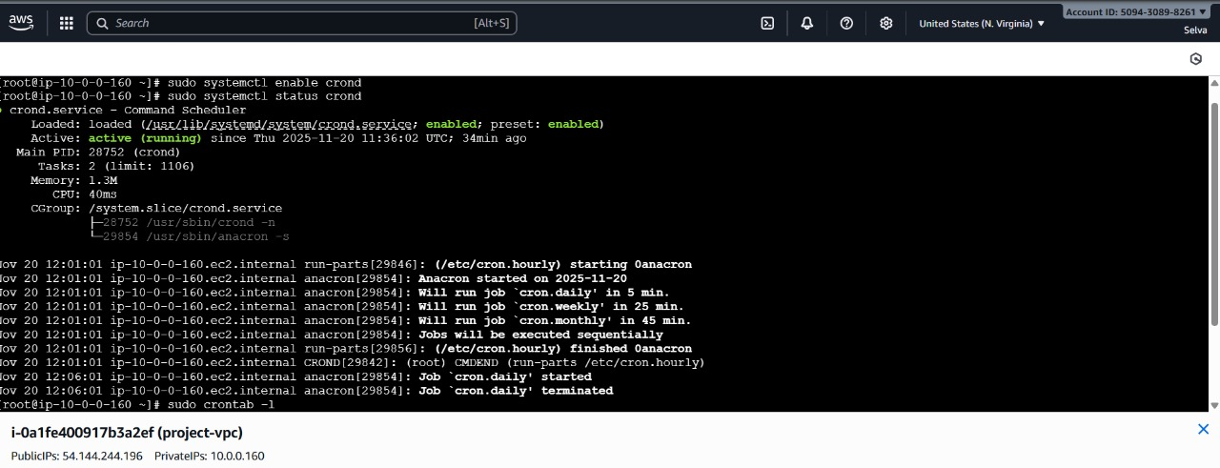

- Test automatic updates: Update a file in S3, wait for the sync, and check for the live change on the EC2-hosted website.
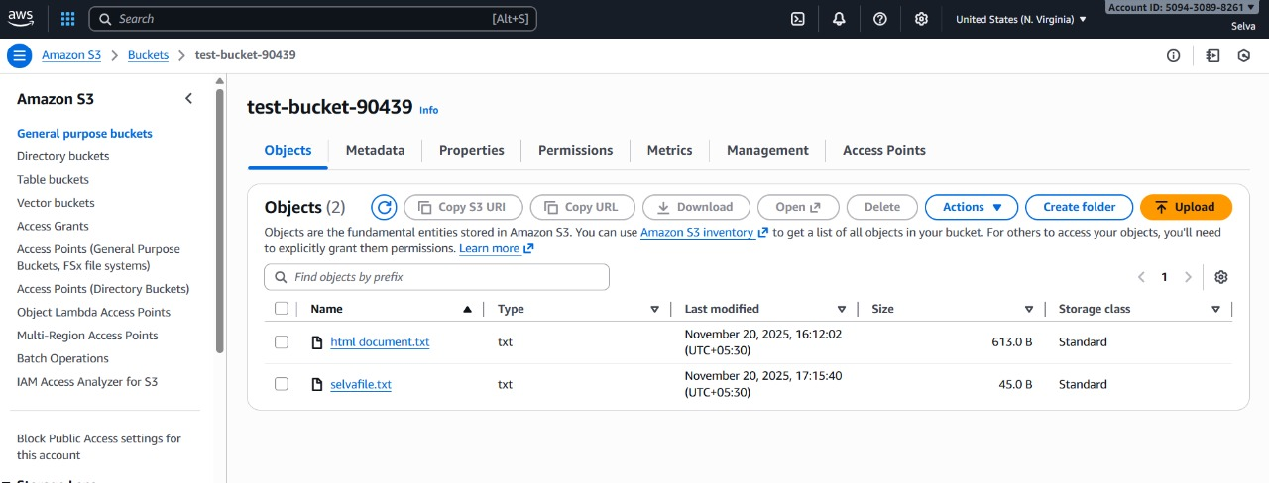

Challenges Faced
- Configuring IAM permissions correctly so EC2 can access only the required S3 bucket.
- Troubleshooting AWS CLI setup issues on EC2 (package installs, credentials).
- Ensuring sync script runs reliably with proper cron job scheduling.
- Managing network access between S3 and EC2 for smooth automation.

Lessons Learned
- Learned practical steps to set up automatic syncing between cloud storage and a server.
- Understood the importance of IAM roles for secure resource access.
- Discovered how AWS CLI and cron jobs are powerful tools for automation.
- Realized the benefits and limitations of using AWS for real-time website hosting.
- Learned to troubleshoot typical cloud deployment challenges.​

Conclusion
This project demonstrates that by combining AWS S3 and EC2, website hosting and updating can be made automatic and highly efficient. Students and new users gain essential skills for cloud-based web deployments. The system reduces manual errors and increases web reliability with simple automation. Through this process, AWS’s flexibility and power for modern hosting solutions have been clearly shown.​

